**ONLINE JOB PORTAL**

#### A PROJECT REPORT

**Submitted By**

Patel Heta N. (170770107565)

Pathan Aayeshasiddiqua A. (170770107594)

Shaikh Afsheen M. (170770107608)

Panchsara Payal C. (180773107515)

***In fulfillment for the award of the degree of***

#### BACHELOR OF ENGINEERING

###### In

**Computer Engineering**



###### SILVER OAK COLLEGE OF ENGINEERING AND TECHNOLOGY

**OPP. BHAGWAT VIDYAPITH, NEAR GOTA CROSS ROAD, AHMEDABAD- 382481.**

**Candidate’s Declaration**

We hereby declare that project report titled “Online Job Portal” submitted towards the completion of project in 8th semester of bachelor of Computer Engineering in Silver Oak College Of Engineering & Technology, Ahmedabad is an authenticate record of our work carried out.

We further declare that to the best of our knowledge the report of C.E.8th semester.

Candidate’s signature **:**

First candidates name **: Patel Heta N.**

Branch **: CE**

Enrollment Number  **170770107565**

Candidate’s signature **:**

Second candidates name **: Pathan Aayeshasiddiqua A.**

Branch **: CE**

Enrollment Number **170770107594**

Candidate’s signature **:**

Third candidates name **: Shaikh Afsheen M.**

Branch **: CE**

Enrollment Number **170770107608**

Candidate’s signature **:**

Fourth candidates name **: Panchsara Payal C.**

Branch **: CE**

Enrollment Number  **180773107515**

Submitted to:

**Silver Oak College Of Engineering & Technology**, Ahmedabad Affiliated to:

###### Gujarat Technological University

**Abstract**

In this 21st century, the education among the people is increasing that the jobs for them are now decreasing. Some people are multitasker .Even the companies want the people who are best or expert in their fields or post .At that particular time, it becomes difficult and time consuming to hire the candidate who is smart and intelligent enough at their work and at the same time honest also. The aim of our project is to develop an online job portal for job seekers and company manager in more convenient way.

Job portal is a website which connects employer and job seekers where employers are the person who post and delete the job and the job seeker can find and apply for the job of their choices. This project will allow the candidate to apply for a job of their choice and vacancy available at company.

#### ACKNOWLEDGEMENT

We are heartily thankful to my supervisor, Mr. Brijesh Hansaliya, whose encouragement, supervision and support from the preliminary to the concluding level enabled me to develop an understanding of the subject. At the end, we offer my regards and blessings to all of those who supported us in any respect during the completion of the project and to our college for providing a resources and materials.

|  |  |  |
| --- | --- | --- |
| **2.1** | **Incremental model** | **10** |
| **2.2** | **Pie chart** | **11** |
| **2.3** | **Roles & Responsibilities** | **12** |
| **4.1** | **Use case** | **25** |
| **4.4** | **Activity diagram** | **26** |
| **4.8** | **Sequence diagram** | **29** |
| **4.10** | **E-R diagram** | **31** |
| **4.11** | **Class diagram** | **32** |
| **5.1** | **Flow chart** | **53** |
| **5.4** | **State transaction diagram** | **54** |

|  |  |  |
| --- | --- | --- |
| **2.1** | **Project plan** | **10** |
| **2.2** | **Milestone and deliverables** | **12** |
| **4.1** | **Login** | **33** |
| **4.2** | **Candidate Education** | **33** |
| **4.3** | **Candidate skill** | **34** |
| **4.4** | **Candidate work experience** | **35** |
| **4.5** | **Candidate personal detail** | **36** |
| **4.6** | **Applied candidate** | **37** |
| **4.7** | **Candidate resume** | **38** |
| **4.8** | **Employee detail** | **39** |
| **4.9** | **Favorite job** | **40** |
| **4.10** | **Posted job** | **41** |
| **5** | **Database Tables:** |  |
| **5.1** | **Login** | **49** |
| **5.2** | **Candidate Education** | **50** |
| **5.3** | **Candidate skill** | **50** |
| **5.4** | **Candidate work experience** | **50** |
| **5.5** | **Candidate personal detail** | **50** |
| **5.6** | **Applied candidate** | **51** |

**INDEX**

**Chapter No Title Page No.**

**. Introduction**

###### 1 Project Summary 2

###### 1.1 Project Scope 3

###### 1.2 Objective 3

###### 1.3 Technologies and Literature Review 4

###### 2 Software Project management

###### 2.1 Project Planning and Scheduling 8

* + 1. 2.1.1 Project Planning  **8**
    2. 2.1.2 Project Scheduling  **8**

###### 2.2 Project Development Approach 8

###### 2.3 Project Plan 10

* + 1. 2.3.1 Milestone and Deliverables  **11**
    2. 2.3.2 Roles and Responsibilities  **12**
    3. 2.3.3 Cost Estimation  **13**
    4. 2.3.4 The COCOMO Model **13**

###### SYSTEM REQUIREMENT STUDY

###### 3.1 User Characteristics 19

###### 3.2 Hardware and Software Characteristics 19

###### 3.3 Constraints 20

* + 1. Hardware Limitation 20

4. System Analysis

4.1 Study of Current System 21

4.2 Requirement of this System 21

4.1.1 Functional Requirement  **21**

4.1.2 Non functional requirement  **22**

4.3 Feasibility Study 22

4.4 Requirement Validation 24

4.5 Function of the System 24

4.5.2 Activity Diagram  **26**

4.5.1 Use-Case **2****4**

4.5.3 Sequence Diagram  **28**

4.6 Data Modeling  31

4.6.1 E-R Diagram**31**

4.6.2Class Diagram **32**

4.5.1 Data Dictionary **33**

4.7 Main modules of new system 43

4.8 Justification  44

5 System Design

5.1 Database design/database structure design 49

* + 1. Mapping Object/Classes to

Object **49**

* 1. System procedural design 52

5.2.1 Design Pseudo code or algorithm for method or **52**

operation

5.2.2 Flow chart diagram  **53**

5.3 Data modeling 54

5.3.1 State Transition Diagrams  **54**

|  |  |  |
| --- | --- | --- |
| **6** | **Implementation Planning and Details** |  |
| **6.1 Implementation Environment** | |  |
| **6.2 Program Modules and Specification** | |  |
| **6.3 Security features**  **6.4 Coding Standards**    **6.5 Sample Coding** | |  |
|  | |  |
|  | |  |
| **7** | **Testing** |  |
| **7.1 Test plan** | |  |
| **7.2 Testing Strategy** | |  |
| **7.3 Test methods** | |  |
| **7.4 Test case** | |  |
| **8** | **Screenshots and User Manual** |  |
|  | **8.1 Homepage** |  |
| **8.2 Registration page**  **8.3 Login screen** |  |

**CHAPTER: 1 INTRODUCTION**

**CHAPTER 1 INTRODUCTION**

**Project Summary**

 Our Online Job Portal is a web application.

 Our aim is to developed an interactive website which help job seeker to find a job related to their skills and choice.

 The objective of our project is to provide features and functions to jobseekers to post or upload their resumes and find appropriate jobs while companies can post their job vacancies and find eligible candidates.

 It enables job seekers to post their resume, generate their resume, and generate video

resume search for jobs, view job listings.

 It will provide companies to place their vacancy job list on the site and have an option to

find an eligible candidate for that position.

### Purpose:

 The purpose of our Job Portal is to give the job seekers a platform for finding a right and satisfactory job according to their qualification or choices

 It connects the job seekers, employer and company.

Job Portal is prepared for all categories of job and help to get the various types of job to the job seeker.

The main purpose of job portal is to provide the more convenient and easy way to get job to the job seekers.

### Scope:

 It will contain all the information of Company, Employer and job seekers.

 It will contain all the information of Job Seeker like Personal Details, Professional Details, Educational Details, etc. which are present in database.

 It will process and evaluate jobs registered by the companies

 It will contain information related to Job Expiry.

 It will maintain Job Seekers, Employer and applied candidate records.

 It will maintain uploaded resumes in database will full privacy.

### Technology and Literature Review:

 The front end used in our project is JQuery, HTML, JavaScript, CSS, Python and the back end used is Sqlite3.

 Tools used are Visual Studio Code.

 We will follow the Iterative model for developing this Project and whole Project will be developed using the SDLC scenario.

###### HTML

 HTML an initialize of Hyper Text Markup Language for web pages.

 HTML is the standard markup language for documents designed to displayed in a web browser. It can be assisted by technologies such Cascading Style Sheets (CSS) and scripting languages such as JavaScript.

 HTML code ensures the proper formatting of text and images for your Internet

browser. Without HTML, a browser would not know how to display text as elements

or load images or other elements.

**JavaScript:**

 JavaScript is a full-fledged dynamic programming language that can add interactivity

to a website. Third-party frameworks and libraries that you can apply to HTML to

accelerate the work of building sites and applications.

###### 

 It is lightweight and most commonly used as a part of web pages, whose implementaions

allow client-side script to interact with the user and make dynamic pages. It is an interpreted programming language with object-oriented capabilities.

.

**CSS:**

CSS stands for Cascading Style Sheets.

CSS is the language it use to style an HTML document.

CSS describes how HTML elements should be displayed

CSS is used to define styles for your web pages, including the design, layout and



variations in display for different devices and screen sizes.

Cascading style sheets are used to format the layout of Web pages.

**Python:**

 Python is an interpreted, object-oriented, high-level programming language with

dynamic semantics.

 Python supports modules and packages, which encourages program modularity and

code reuse.

 Python offers many frameworks from which to choose from including bottle.py, Flask,

CherryPy, Pyramid, Django and web2py.

**JQuery:**

 The purpose of jQuery is to make it much easier to use JavaScript on your website.

 jQuery takes a lot of common tasks that require many lines of JavaScript code to accomplish,

and wraps them into methods that you can call with a single line of code.

**Django:**

Django is a high-level Python web framework that enables rapid development of secure

and maintainable websites. Built by experienced developers, Django takes care of much

of the hassle of web development, so you can focus on writing your app without needing

to reinvent the wheel**.**

 Django is the best framework for web applications, as it allows developers to use

modules for faster development. As a developer, you can make use of these modules

to create apps, websites from an existing source. It speeds up the development process

greatly, as you do not have to code everything from scratch.

# CHAPTER: 2

## SOFTWARE PROJECT MANAGEMENT

### CHAPTER 2 SOFTWARE PROJECT MANAGEMENT

**Project planning and scheduling**

#### Project Planning

* + - * Project planning is part of project management, which relates to the use of schedules such as Gantt charts to plan and subsequently report progress within the project environment.
      * Initially, the project scope is defined and the appropriate methods for completing the project are determined. Following this step, the durations for the various tasks necessary to complete the work are listed and grouped into a work breakdown structure.
      * Project planning is often used to organize different areas of a project, including project plans, workloads and the management of teams and individuals.

#### Project Scheduling

* + - * Project Scheduling is the culmination of a planning activity that is primary component of software project management.
      * When combined with estimation methods and risk analysis, scheduling, establishes a road map for the project management.
      * Scheduling begins with the process composition. The characteristics of the project are used to adapt an appropriate task set for the work to be done.
      * The task network is used to compute the critical project path, a time line chart and a variety of project information.

### Project Development Approach

The activities we followed for this project is listed below:

* Planning the work or objectives
* Analysis & Design of objectives
* Assessing and controlling risk
* Allocation of resources
* Organizing the work
* Database Designing
* Form Design

The Process Paradigm we used for our project is Incremental Model.

###### The Incremental Software Process Model

* + The Incremental Model combines elements of the linear sequential model with the iterative philosophy of prototyping. The incremental model applies linear sequences in a staged fashion as calendar time progresses.
  + Each linear sequence produces a deliverable “increment” of the software. For example, word processing software developed using the incremental paradigm might deliver basic file management, editing and document production functions in the first increment; more sophisticated editing and document production capabilities in the second increment; spelling and grammar checking in the third increment; and advanced page layout capability in the fourth increment.
  + It should be noted that the process flow for any increment can incorporate the prototyping paradigm.
  + When an incremental model is used, the first increment is often a core product. That is, basic requirements are addressed, but many supplementary features remain undelivered.
  + The core product is used by the customer. As a result of use and/or evaluation, a plan is developed for the next increment. The plan addresses the modification of the core product to better meet the needs of the customer and the delivery of additional features and functionality.
  + This process is repeated following the delivery of each increment, until the complete product is produced.
  + The Incremental process model, like prototyping and other evolution approaches, is iterative in nature.
  + But unlike prototyping, the incremental model focuses on the delivery of an operational product with each increment.
  + Early increments are stripped down versions of the final product, but they do provide capability that serves the user and also provide a platform for evaluation by the user.

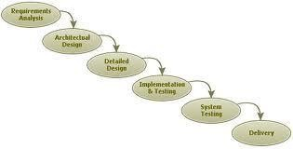

Figure 2.1 Incremental Model

|  |  |  |
| --- | --- | --- |
|  | **From Date** | **To Date** |
| **1.Preliminary Investigation** | 30/08/2020 | 15/08/2020 |
| **2.Requirment Analysis** | 16/08/2020 | 02/09/2020 |
| **3.Designing** | 03/09/2020 | 16/09/2020 |
| **4.Implementation** | 17/10/2020 | Half done |
| **5.Testing** | - | - |

### Project Plan

[Table 2. 1 Project Plan]

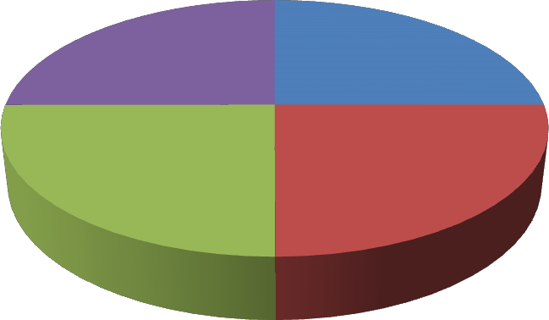

design

25%

Coding

25%

Analysis

25%

Testing

25%

**Start Date**

[ Figure 2.2 Pie Chart]

#### Milestone and Deliverables

* + - * In this project, we went through Module Wise Completion. First we did analysis of first module; we went through all the requirements for first module that is Admin Module.
      * By this analysis we decided field of all the tables of Admin Module. Then we started Database Design.
      * After competing it we started with the design of all forms of this module. Then we did coding and finally validations and testing of forms that we made.
      * After completing the first module we started the same procedure for the Member Module.
      * After that we completed User Module. Between this we did settings forms e.g. Change theme, change background color of the main screen etc.
      * There was continuously interaction with the client that was very beneficial for us.
      * When we completed whole project we started testing the whole project for final verification.
      * Then we started documentation of our project. Finally, we completed the project with client’s satisfaction.
      * A milestone is an end point of software process activity.

|  |  |
| --- | --- |
| **Software Process Activity** | **Milestones** |
| Project Plan | Project Schedule |
| Requirement Collection | User requirements |
| Data Flow Analysis | System Flow |
| Design   1. Database Design 2. User Interface Design 3. System Design | System Design Document |
| Implementation   1. Code For giving security 2. Code for reports | Access Reports Reports |
| Testing | Setting validation and error message |

[Table 2. 2 Milestones and Deliverables]

#### Roles and Responsibilities

Afsheen and Aayeshasiddiqua

1. Investigation
2. Requirement Analysis
3. DB Design
4. Coding

**Job**

**Portal**

Payal and Heta

1. Investigation
2. Requirement Analysis
3. DB Design
4. Coding

[Figure 2.3 Roles and Responsibilities]

#### Gantt Chart

|  |  |  |  |  |  |  |  |  |  |  |  |  |  |  |  |
| --- | --- | --- | --- | --- | --- | --- | --- | --- | --- | --- | --- | --- | --- | --- | --- |
| *ID* | *Task Name* | *Start* | *Finish* | *Duration* | *2020* | | | | | | *2021* | | | | |
| *Jul* | *Aug* | *Sep* | *Oct* | *Nov* | *Dec* | *Jan* | *Feb* | *Mar* | *Apr* |  |
| 1 | Preliminary Investigation | 30/07/2020 | 15/08/2020 | 2.2w |  |  | | | | | | | | | |
| 2 | Requirement Analysis | 16/08/2020 | 02/09/2020 | 2.3w |  | | | | | | | | | | |
| 3 | Design | 03/08/2020 | 16/09/2020 | 2.0w |  | | | | | | | | | | |
| 4 | Implementation | 17/09/2020 | - | - |  | | | | | | | | | | |
| 5 | Testing | - | - | - |  | | | | | | | | | | |

###### Cost Estimation:

**The COCOMO Model**

* + - * Like all estimation models for software, the COCOMO models require sizing information.
      * Three different sizing options are available as part of the model hierarchy: object points, function points, and lines of source code.
      * Like function points, the object point is indirect software that is computed using counts of the number of

1. Screens (at the user interface),
2. Reports,
3. Components likely to be required to build the application.
   * Once complexity is determined, the number of screens, reports, and components are weighted according to Table above.
   * The object point count is then determined by multiplying the original number of object instances by the weighting factor in table above and summing to obtain a total object point count.
   * When component based development or general software reuse is to be applied, the percent of reuse (%reuse) is estimated and the object point count is adjusted:

###### NOP = (object points) X [(100 - %reuse) / 100].

* + Where NOP is defined as new object points. To derive an estimate of effort based on the computed NOP value, a “productivity rate” must be derived.

###### PROD=NOP / person-month

* + For different levels of developer experience and development environment maturity. Once the productivity rate has been determined, an estimate of project effort can be derived as Estimated effort = NOP/PROD.
  + There are three types of software project:
    - Organic project
    - Semi-deteched project\
    - Embedded project

###### Cost required to develop project=effort*rs/month

* + **Effort Estimation (E):**

In Organic=2.4 (KLOC)1.05 PM

In semidetached=3.0(KLOC)1.12 PM In Embedded=3.6(KLOC)1.20PM

###### Duration Estimation (D):

In Organic=2.5(effort)0.38months

In semidetached=2.5(effort)0.35 months In Embedded=2.5((effort)0.32months

###### Person Estimation:

P=E/D

###### KLOC=Kilo Line of Code

* + Total line of code=12,535
  + KLOC=12.54

We are using Organic Project Type,

###### Effort Estimation (E):

=2.4 (KLOC)1.05 PM

=33.30 PM

###### Duration Estimation (D):

= 2.5(effort)0.38 month

=2.5(33.30)0.38 months

=9.5 months

###### Project Cost:

=effort*RS/month

=33.30*12000

=3, 99,600 RS

###### Advantages of COCOMO:

* + - COCOMO is factual and easy to interpret.
    - One can clearly understand how it works.
    - Accounts for various factors that affect cost of the project.
    - Works on historical data and hence is **more** predictable and accurate.

###### Disadvantages:

* + - COCOMO model ignores requirements and all documentation.
    - It ignores **customer skills**, cooperation, knowledge and other parameters.
    - It oversimplifies the impact of safety/security aspects.
    - It ignores hardware issues
    - It ignores personnel turnover levels
    - It is dependent on the amount of time spent in each phase.

# CHAPTER 3

**SYSTEM REQUIREMENT**

**STUDY**

### CHAPTER 3 SYSTEM REQUIREMENT STUDY

* 1. **User Characteristics:**
     + It describes the type of user which deals with the applications. This website has three types of users or module as given below:

1. Admin
2. Employer(Company Manager)
3. Job seeker

###### Admin:

###### This module provides admin related functions. Admin can manage entire website and

###### will also maintains the profiles of applicants, registered candidate and employers.

###### Employer:

###### This module provides functions related to employers. Employers can post vacancy

###### details and update the details as and when necessary and delete when vacancy is filled .

###### Employers can go through candidate resumes based on different criteria related to

###### their job position.

###### Job seeker:

###### This module provides functions related to job seekers. Candidate can post their resumes

###### or use feature video resume to generate video resume. The applicant can also search through

###### the present vacancies available. Job seekers can also get notifications when their resumes are

###### selected by employers or when there is any vacancy related to their choice or qualification.

###### 

**Hardware and Software Characteristics:**

#### Hardware Requirements:

* + - Processor: Intel core i7
    - Processor Speed: 3.40 GHz
    - RAM: 8 GB

#### Software Requirements:

* + - * Operating System: Window XP, Windows-7
      * Front-end: HTML, JavaScript
      * Back-end: PHP, MYSQL
      * Supporting Server: Apache Tomcat 5.5, WampServer

#### Hardware requirement for Web Application Development

* + - * Minimum 2.0 GHz processor
      * Minimum 2GB of RAM
      * 100GB free space in Hard Disk storage

#### Software requirement for Web Application Development

* + - * Visual studio code
      * My SQL Database
      * Nodejs library

### Constraints:

* + - * The users access the Online Job Portal System from any computer that has Internet browsing capabilities and an Internet connection.
      * User can access it from anywhere like public area ,office and home.

#### Hardware Limitation

* + - * The smooth functionality of the portal mainly depends on the speed of hardware and then on speed of the internet.
      * It is always advisable to be update as far as hardware is concerned. The hardware limitation occurs if the user is still using a very low MHz processor or a RAM or less than128Mb.
      * This will generally reduce the portal and also the use will waste a lot of useful time, energy and resources.

# CHAPTER 4 SYSTEM ANALYSIS

### CHAPTER 4 SYSTEM ANALYSIS

### Study of Current System

* + - Currently there are many applications and website but there are some problems in

those apps and website like authentication, verification and many more.

### Requirement of this System

* + - We are developing an online job portal. By using this portal, the job seeker and employer will task become easy and job seeker can search their jobs related to their choice and company can get eligible candidate in very efficient and convenient manner
    - We are developing our portal on this interactive concept.

#### Functional Requirement:

###### User Requirement:

* + - * User who uses this portal should know how to operate the windows. Because the software has the same look and features like whole software is menu driven.
      * Just click and corresponding thin from menu of hyperlink will be opened.

#### Identification of functional requirement:

* + - * The high level functional requirement often needs to be identified from an informal problem description document or from a conceptual understanding of the problem.
      * Each high level requirement characterizes away of system usage by some users to perform some meaningful piece of work.

#### Documentation of functional requirement:

* + - * For documenting the functional requirement we need to specify the set of functionalities supported by the system.
      * A function can be identified the state at which the data to input to the system, its input data domain, the output data domain, and the type of possessing to be carried out on the input data to obtain the output data.

#### Non functional requirement:

###### Usability:

* + - * The interface should use terms and concepts, which are drawn from the experience of people who will make most o the system.\

###### Efficiency:

* + - * The portal must provide easy and fast access without consuming more time.

###### Readability:

* + - * User should never be surprised by the behavior of the system and it should also provide meaningful feedback when error occurs so that user can recover from the error.

###### Accuracy:

* + - * The user should require that data are obtained from database and stored in database must be accurate.

###### Security:

* + - * The user wants the data stored in database must be secured and cannot be accessed by unauthorized user.

###### Maintainability:

* + - * User wants that the system should be maintained easily means that if there are some changes required in the system that can be done easily.

### Feasibility Study

* + - Feasibility is the measure of how beneficial the development of information system will be to an organization.
    - The feasibility analysis is categorized under four different types.

1. Schedule Feasibility
2. Economic Feasibility

###### Operational Feasibility:

* + The System is to be developed for any user who wants to use it. We want our system user friendly and easy to use.
  + The administrator also may be non-technical, so the user interface will be designed in such a way that it gets comfortable for non-technical person to operate easily.

###### Technical Feasibility:

* + It is a partially measurement of specific technical solution and the availability of technical resorts and expertise.
  + The analyst must find out whether the current technical resources, which are available in the system is capable of handling the job.
  + If not, then the analyst with the help of developer should confirm whether the technology is available and capable or not.

###### Better Considering:

* + Here we have to consider those tools which are required for developing the project.
  + As far as basic knowledge concerned we have studied basic of objective-C and SQL.

###### Schedule Feasibility:

* + Schedule feasibility corresponds to whether sufficient time is available to complete the project.

###### Factor considered:

* + Schedule of the project
  + Time by which project has to be completed
  + Reporting period

###### Economic feasibility:

* + Economic feasibility is a measure of cost effectiveness of a project or solution.
  + For declaring that the system is economically feasible, the benefits from the project should exceed or at least to the equal to the cost of development.

### Requirement Validation:

* + - Requirement validation examines this specification to ensure that all the system requirements have been stated unambiguously.
    - These inconsistent, error have been detected and corrected and the work products confirmed to the standard.
    - Source of the requirement are identified, final Statement of requirement has been examined by original source.
    - Requirements related to main requirements are founds.
    - Requirements are clarifying stated and are not misinterpreted.
    - All sources of requirements are covered to get a maximum requirement.
    - All method of finding requirements is applied.

### Function of the System:

#### Use-Case:

* + - * In software and systems engineering, a **use case** is a list of steps, typically defining interactions between actor and a system, to achieve a goal.
      * The actor can be a human, an external system, or time.
      * In systems engineering, use cases are used at a higher level than within software engineering, often representing missions or stakeholder goals.
      * The detailed requirements may then be captured in Systems Modeling Language or as contractual statements.
      * As an important requirement technique, use cases have been widely used in modern software engineering over the last two decades.
      * Use case driven development is a key characteristic of process models and frameworks.
      * With its iterative and evolutionary nature, use case is also a good fit for agile development.

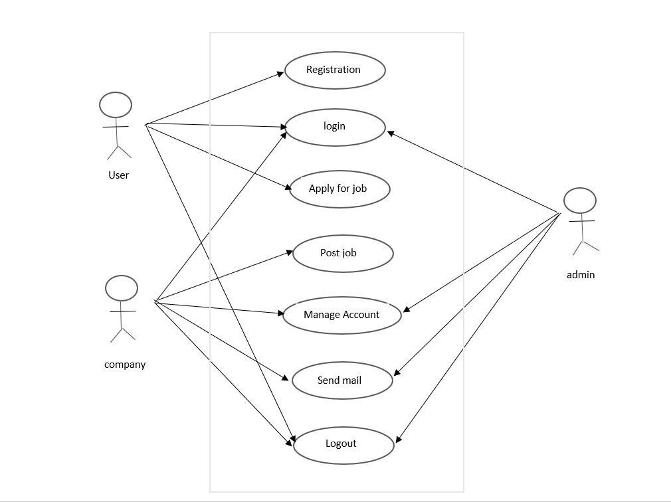

[Figure 4.1 Use-Case]

#### Activity Diagram:

#### Company :

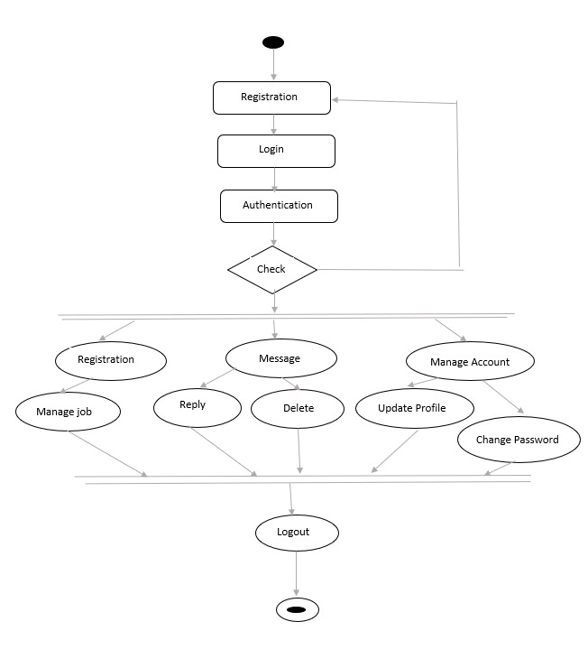

**Job seeker :**

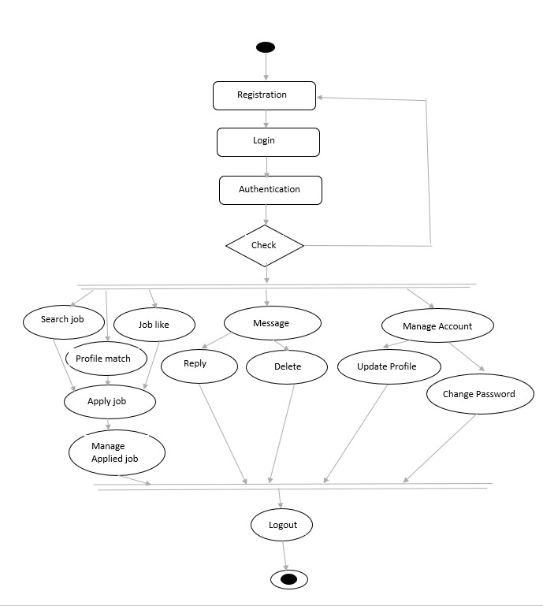

[Figure 4.1 Activity Diagram]

#### Sequence Diagram:

* + - * The well-known [Message Sequence Chart](http://en.wikipedia.org/wiki/Message_Sequence_Chart) technique has been incorporated into the [Unified Modeling Language (UML) diagram](http://en.wikipedia.org/wiki/Unified_Modeling_Language) under the name of **Sequence Diagram**.
      * A sequence diagram shows, as parallel vertical lines, different processes or objects that live simultaneously, and, as horizontal arrows, the messages exchanged between them, in the order in which they occur.
      * This allows the specification of simple runtime scenarios in a graphical manner.
* The well-known [Message Sequence Chart](http://en.wikipedia.org/wiki/Message_Sequence_Chart) technique has been incorporated into the [Unified Modeling Language (UML) diagram](http://en.wikipedia.org/wiki/Unified_Modeling_Language) under the name of **Sequence Diagram**. A sequence diagram shows, as parallel vertical lines, different processes or objects that live simultaneously, and, as horizontal arrows, the messages exchanged between them, in the order in which they occur. This allows the specification of simple runtime scenarios in a graphical manner.

###### Admin

###### Sequence1.jpg

### Data Modeling:

#### E-R Diagram:

* + - * In software engineering, an **entity–relationship model** (**ER model**) is a data model for describing the data or information aspects of a business domain or its process requirements, in an abstract way that lends itself to ultimately being implemented in a database such as a relational database.
      * The main components of ER models are entities and the relationships that can exist among them, and databases. An entity-relationship model is a systematic way of describing and defining a business process.
      * The process is modeled as components (entities) that are linked with each other by relationships that express the dependencies and requirements between them, such as: one building may be divided into zero or more apartments, but one apartment can only be located in one building. Entities may have various properties (attributes) that characterize them.
      * Diagrams created to represent these entities, attributes, and relationships graphically are called entity–relationship diagrams.

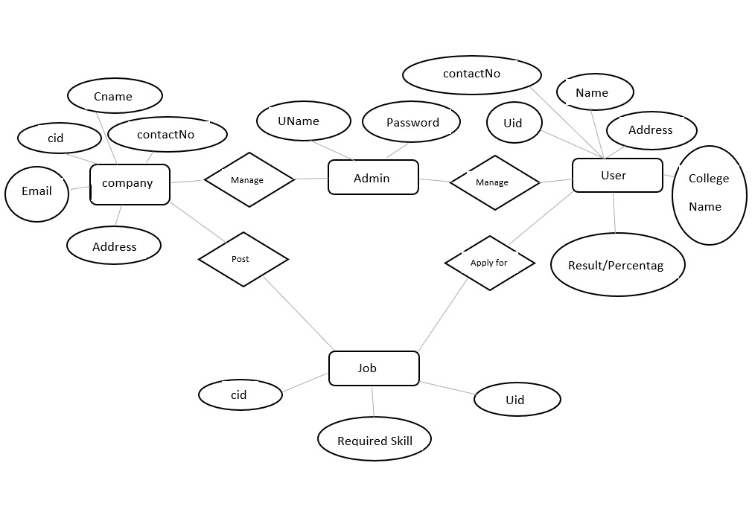

#### Class Diagram:

 In software engineering, a **class diagram** in the Unified Modeling Language (UML) is a type of static structure diagram that describes the structure of a system by showing the system's classes, their attributes, operations (or methods), and the relationships among objects.

 The class diagram is the main building block of object oriented modeling.

 It is used both for general conceptual modeling of the systematic of the application, and for detailed modeling translating the models into programming code.

 Class diagrams can also be used for data modeling.

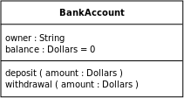 The classes in a class diagram represent both the main objects, interactions in the application and the classes to be programmed.

 In the diagram, classes are represented with boxes which contain three parts:

 The top part contains the name of the class. It is printed in Bold, centered and the first letter capitalized.

 The middle part contains the attributes of the class. They are left aligned and the first letter is lower case.

 The bottom part gives the methods or operations the class can take or undertake. They are also left aligned and the first letter is lower case.

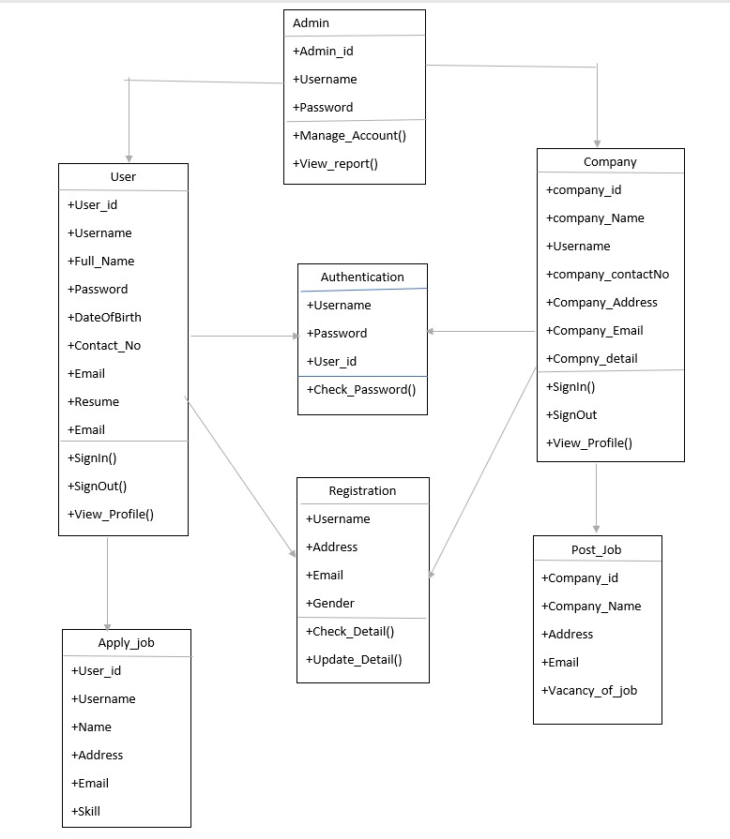

**Data Dictionary:**

|  |  |  |  |  |  |
| --- | --- | --- | --- | --- | --- |
| **Project Name:** Job portal | | | **Table Name:** login | | |
| **Primary key: User id** | | | **Foreign key: -** | | |
| **Table Description:** This table is for description about login | | | | | |
| **Table Structure** | | | | | |
| **Field Name** | **Data Type** | **Size** | | **Constrains** | **Description** |
| User id | Int | 20 | | Primary key | This field contains User id. |
| User name | Varchar | 20 | | Unique key | This field contains user name  . |
| Password | Varchar | 20 | | Unique key | This field contains password  . |

|  |  |  |  |  |  |
| --- | --- | --- | --- | --- | --- |
| **Project Name:** Job portal | | | **Table Name:** Candidate Education | | |
| **Primary key:**  Education id | | | **Foreign key:**  Candidate Eid | | |
| **Table Description:** This table is for description about Candidate Education . | | | | | |
| **Table Structure** | | | | | |
| **Field Name** | **Data Type** | **Size** | | **Constrains** | **Description** |
| Education id | Int | 20 | | Primary key | This field contains Education id. |
| Candidate EId | Int | 50 | | Foreign key | This field contains candidate Eid  . |
| Qualification Level | Varchar | 50 | | Not null | This field contains Cndidate’s stream and Degree |
| Qualification Specification | Varchar | 50 | | Not null | This field contains company name. |
| Passing Year | Int | 10 | | Not null | This field contains Passing Year |

|  |  |  |  |  |  |
| --- | --- | --- | --- | --- | --- |
| **Project Name:** Job portal | | | **Table Name:** Candidate Skill | | |
| **Primary key:**  Skill Id | | | **Foreign key:**  Candidate Sid | | |
| **Table Description:** This table is for description about Candidate Skill | | | | | |
| **Table Structure** | | | | | |
| **Field Name** | **Data Type** | **Size** | | **Constrains** | **Description** |
| Skill Id | Int | 20 | | Primary key | This field contains Skill Id |
| Candidate SId | Varchar | 40 | | Foreign key | This field contains Candidate SId . |
| Skills | Varchar | 90 | | Not null | This field contains Skills. |
| Experience Year | Int | 20 | | Not null | This field contains Experience Year. |
| Experience Months | Int | 10 | | Not null | This field contains Experience Months |

|  |  |  |  |  |  |
| --- | --- | --- | --- | --- | --- |
| **Project Name:** Job portal | | | **Table Name:** Candidate Work Experience | | |
| **Primary key:**  Experience Id | | | **Foreign key:**  Candidate WEId | | |
| **Table Description:** This table is for description about Candidate Work Experience . | | | | | |
| **Table Structure** | | | | | |
| **Field Name** | **Data Type** | **Size** | | **Constrains** | **Description** |
| Experience Id | Int | 18 | | Primary key | This field contains  Experience Id |
| Candidate WEId | Int | 18 | | Foreign key | This field contains  Candidate WEId |
| Candidate Type | Varchar | 100 | | Not null | This field contains  Candidate Type |
| Job Title | Varchar | 50 | | Null | This field contains  Job Title |
| Experience Year | Int | 10 | | Null | This field contains  Experience Year |
| Experience Months | Int | 10 | | Null | This field contains  Experience Months |
| Annual Salary | Varchar | 10 | | Null | This field contains  Annual Salary |
| Functional Area | Varchar | 50 | | Not null | This field contains  Functional Area |

|  |  |  |  |  |  |
| --- | --- | --- | --- | --- | --- |
| **Project Name:** Job portal | | | **Table Name:** Candidate Personal Detail | | |
| **Primary key:**  Personal Detail Id | | | **Foreign key:**  Candidate PId | | |
| **Table Description:** This table is for description about Candidate Personal Detail | | | | | |
| **Table Structure** | | | | | |
| **Field Name** | **Data Type** | **Size** | | **Constrains** | **Description** |
| Personal Detail Id | Integer | 18 | | Primary key | This field contains Personal Detail Id . |
| Candidate PId | Integer | 18 | | Foreign key | This field contains Candidate PId . |
| Full Name | Varchar | 100 | | Not null | This field contains Full Name |
| Email | Varchar | 100 | | Not null | This field contains Email . |
| Contact Number | Integer | 10 | | Not null | This field contains Contact Number . |
| City | Varchar | 50 | | Not null | This field contains City |
| Country | Varchar | 50 | | Not null | This field contains Country |
| Date Of Birth | Date |  | | Not null | This field contains Date Of Birth |
| Created On | Date |  | | Not null | This field contains candidate updated profile |
| Updated On | Date |  | | Not null | This field contains candidate updated profile |

|  |  |  |  |  |  |
| --- | --- | --- | --- | --- | --- |
| **Project Name:**  Job portal | | | **Table Name:** Applied Candidates | | |
| **Primary key:**  Applied Job_id | | | **Foreign key:**  Candidate Apply Id, Job Id | | |
| **Table Description:** This table is for description about Applied Candidates . | | | | | |
| **Table Structure** | | | | | |
| **Field Name** | **Data Type** | **Size** | | **Constrains** | **Description** |
| Applied Job_id | Integer | 18 | | Primary key | This field contains Skill id. |
| Candidate Apply Id | Integer | 18 | | Foreign key | This field contains Candidate Apply Id |
| Job Id | Integer | 18 | | Foreign key | This field contains Job Id |
| Cover Letter | Ntext |  | | Not null | This field contains Candidate Cover Letter |

|  |  |  |  |  |  |
| --- | --- | --- | --- | --- | --- |
| **Project Name:** Job portal | | | **Table Name:** Candidate Resume | | |
| **Primary key:**ta Resume Id | | | **Foreign key:**  Candidate CVId | | |
| **Table Description:** This table is for description about Candidate Resume | | | | | |
| **Table Structure** | | | | | |
| **Field Name** | **Data Type** | **Size** | | **Constrains** | **Description** |
| Resume Id | Integer | 20 | | Primary key | This field contains Resume Id |
| Candidate CVId | Integer | 50 | | Foreign key | This field contains Candidate CVId |
| File Name | Varchar | 20 | | Not null | This field contains File Name |
| File Date | Date |  | | Not null | This field contains File Date |
| File extension | Varchar |  | | Not null | This field contains File extension |

|  |  |  |  |  |  |
| --- | --- | --- | --- | --- | --- |
| **Project Name:** Job portal | | | **Table Name:** Employee Detail | | |
| **Primary key:**- | | | **Foreign key:** Employee Id | | |
| **Table Description:** This table is for description about time schedule. | | | | | |
| **Table Structure** | | | | | |
| **Field Name** | **Data Type** | **Size** | | **Constrains** | **Description** |
| Employee Id | Integer | 20 | | Foreign key | This field contains Employee Id |
| Company Name | Varchar | 20 | | Not null | This field contains Company Name. |
| Company URL | Varchar | 20 | | Not null | This field contains Company URL |
| Owner Name | Varchar | 20 | | Not null | This field contains Owner Name. |
| About Company | Varchar | 200 | | Null | This field contains About Company |

|  |  |  |  |  |  |
| --- | --- | --- | --- | --- | --- |
| **Project Name:** Job portal | | | **Table Name:** Favorite Jobs | | |
| **Primary key:** Favorite Job Id | | | **Foreign key:**  Job Id, Candidate Id | | |
| **Table Description:** This table is for description about Favorite Jobs | | | | | |
| **Table Structure** | | | | | |
| **Field Name** | **Data Type** | **Size** | | **Constrains** | **Description** |
| Favorite Job Id | Integer | 18 | | Primary key | This field contains Resume Id |
| Job Id | Integer | 18 | | Foreign key | This field contains Job Id |
| Candidate Id | Integer | 18 | | Foreign key | This field contains Candidate Id |
| Job Title | Varchar | 50 | | Not null | This field contains Job Title |
| Location | Varchar | 50 | | Not null | This field contains Location |

|  |  |  |  |  |  |
| --- | --- | --- | --- | --- | --- |
| **Project Name:** Job portal | | | **Table Name:** Posted Jobs | | |
| **Primary key:** Posted Job Id | | | **Foreign key:**  Employer Id, Job Title | | |
| **Table Description:** This table is for description about Posted Jobs | | | | | |
| **Table Structure** | | | | | |
| **Field Name** | **Data Type** | **Size** | | **Constrains** | **Description** |
| Posted Job Id | Integer | 18 | | Primary key | This field contains Resume Id |
| Employer Id | Integer | 18 | | Foreign key | This field contains Employer Id |
| Job Title | Integer | 18 | | Foreign key | This field contains Job Title |
| Target Type | Varchar | 50 | | Not null | This field contains Target Type |
| Telecommunicate | Varchar | 10 | | Not null | This field contains Telecommunicate |
| Relocation | Integer | 20 | | null | This field contains Relocation. |
| Posted Date | Date |  | | Not null | This field contains Posted Date |
| Skill Require | Varchar | 200 | | null | This field contains Skill Require. |
| Job Description | Varchar | 200 | | Null | This field contains Job Description |
| Key Terms | Varchar | 200 | | Not null | This field contains Key Terms |
| Country | Varchar | 50 | | Not null | This field contains Country |
| State | Varchar | 50 | | Not null | This field contains State |
| City | Varchar | 50 | | Not null | This field contains City |
| ZipCode | Integer | 6 | | Null | This field contains ZipCode |
| Minimum Experience | Integer | 10 | | null | This field contains Minimum Experience |
| Status | Varchar | 10 | | Not null | This field contains Status |

### Main Modules of New System

* + - The Online Job Portal will be used to manage jobs. It will support both job seeker and Employer to achieve their goals.
    - The main modules involved in this system are:

1. Admin

2. Job seeker

3. Employer

###### Module Wise description

1. **Administration Module**

* This module provides administrator related functionalities.
* Admin will manage entire application and maintains the profiles of applied candidate,

job seekers and employers.

1. **Job Seeker Module:**

* This module provides functionalities for job seekers.
* Job seeker can upload their resumes.
* Job seekers will notification when their resumes are selected by employers.
* The job seeker can search through the present vacancies available in any company.

1. **Employer Module:**

* This module provides functionalities related to employers.
* Employers can post job vacancy details and update the details as and when necessary depending upon company criteria.
* Employers can search through applied candidate resumes based on different criteria of company.

### Justification:

* The wider areas of job searching improves the quick and easy access to opportunities

which will be helpful to every jobseeker.

* The situation has prompted many to move to job portal to look for the ways that has

been widely accepted and fully useful in job searching and at the same time easy to

access .

**CHAPTER 5 SYSTEM DESIGN**

### CHAPTER 5 SYSTEM DESIGN

Systems design is the process of defining the architecture, components, modules, interfaces, and data for a system to satisfy specified requirements. The System Design Description report provides summary or detailed information about a system design represented by a model. Systems design is therefore the process of defining and developing systems to satisfy specified requirements of the user.

#### database design/database structure design:

Database design is the process of producing a detailed data model of a database. This logical data model contains all the needed logical and physical design choices and physical storage parameters needed to generate a design in a Data Definition Language, which can then be used to create a database. A fully attributed data model contains detailed attributes for each entity.

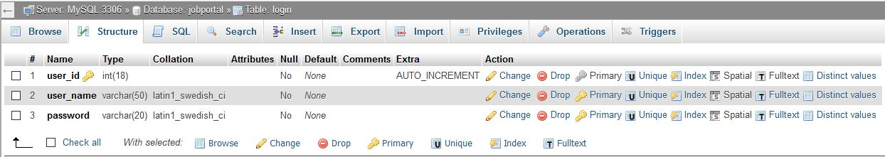

[Table 5. 1 Login]

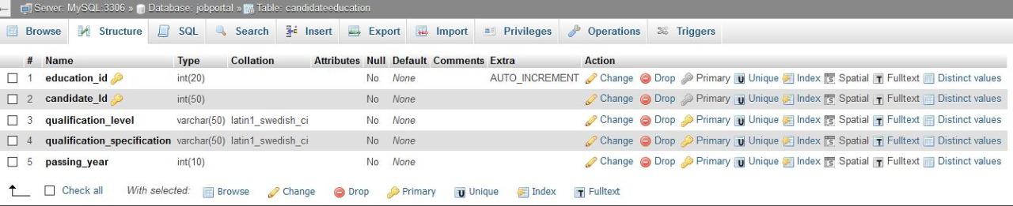

[Table 5. 2 Candidate Education]

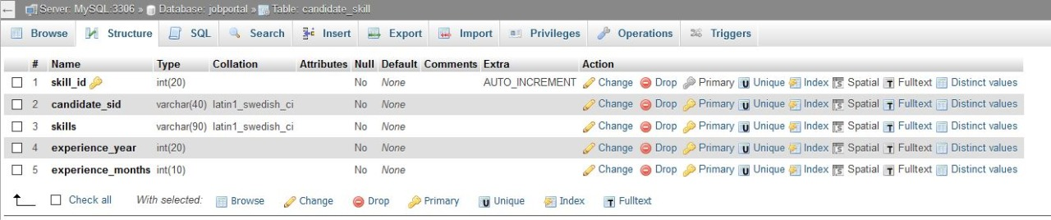

**[**Table 5. 3 Candidate Skill]

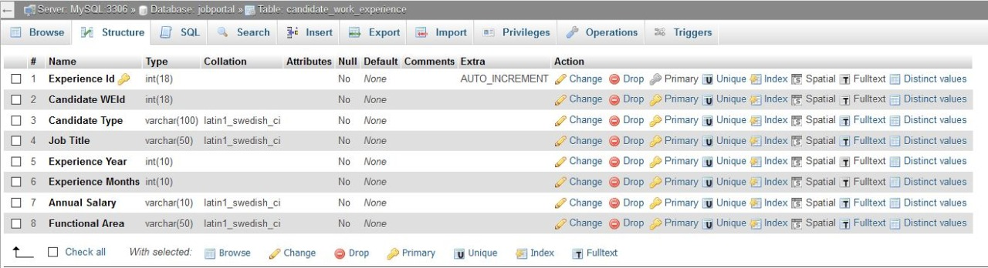

[Table 5. 4 Candidate work experience ]

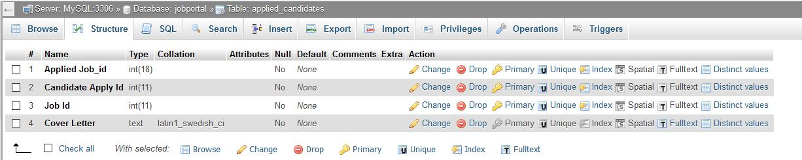

[Table 5. 5 AppliedCandidate ]

### System procedural design

#### Design Pseudo code or algorithm for method or operation

###### Admin side

Step 1: provide user name and password

Step 2: if username and password both is correct then it will login successfully.

Step 3: it shows home page

Step 4: admin can able to perform many operations.

###### User side

Step 1: login to the system.

Step 2: job search as per candidate choice and location.

Step 3: Apply for the job as per user choice .

Step 4: if applied for job then give test or interview.

Step 5: logout from the site.

**Employer**

Step 1: login to the system.

Step 2: post ,delete or update the job vacancy.

Step 3: select the candidate as per requirement of company.

Step 4: conduct the interview of selected candidates.

Step 5: logout from the site.

**Flowchart**

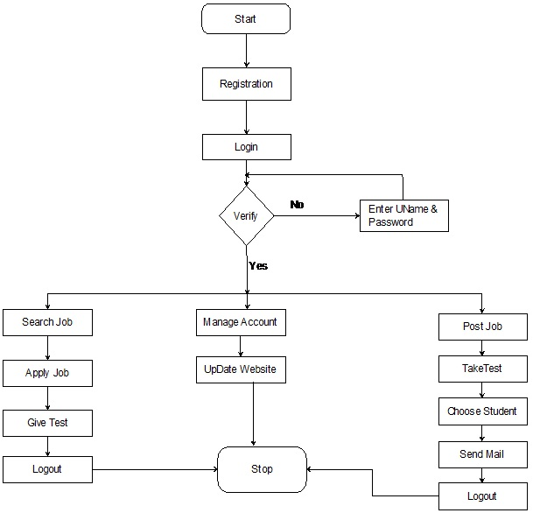

### 

### Data Modeling:

#### State chart diagram

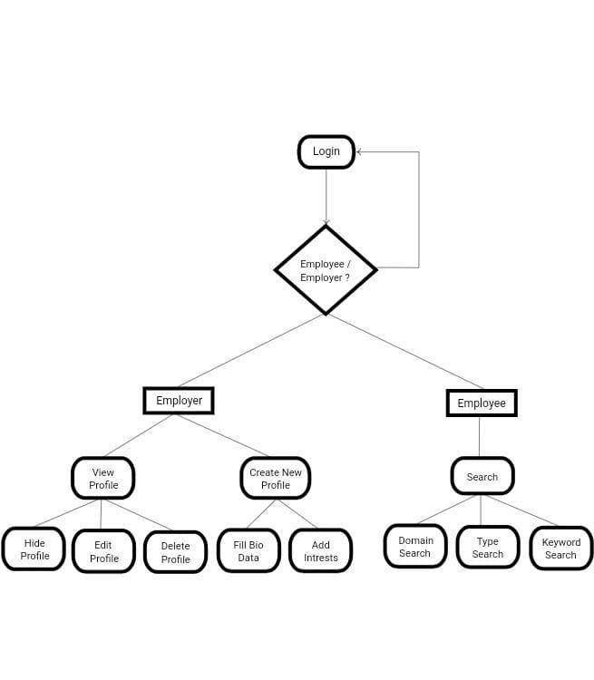

[Figure 5.4 State Chart Diagram]

## CHAPTER 6 IMPLEMENTATION PLANNING AND DETAILS

### Implementation Environment

* + - This describes the technological and physical environment in which the product is to be installed. It includes automated, mechanical, organizational, and other devices, along with the nonhuman adjacent systems.
    - Here product is for job-seekers and job-providers so it will make it easier to for them to connect each other and make it better.

### Program Modules and Specification

* + - Module is the way to improve the structure design by break down the problem for solving it into independent task.

#### Advantages of Module

* + - * It breakdown the problem into independent modules so the complexity of the problem can be minimized.
      * Each independent module can be easily assigned to the various members of the development team.
      * Module can be easily run and tested independently from another.
    - In this software we divided all the parts into multiple subparts so that work on particular part can be easier.
    - Some of major modules are Admin,Employer and Job-sekeer. For backend there are also modules for database connection, control the data flow, process done by all modules.

### Security features

* + - We are using SQLite3 as a Database ,because it requires no configuration and stores information in ordinary disk files. Our motive is to provide secure and reliable software.
    - For Security purpose there are multiple privileges given to the users. As per their permission they can make modifications to specific part for which permission is given the that particular user.
    - Two factor authentications can be enabled by the user if needed. Also pin for the application will be enabled on new device.

### Coding Standards

* + - Coding standards are a set of guidelines, best practices, programming styles and conventions that developers adhere to when writing source code for a project. All big software companies have them.

#### Write Comments and Documentation

* + - * Perhaps one of the first things you learn as a developer is to comment your code. At first it may seem like a waste of time, following the mentality of ‘If they are a developer too they can understand it’. While it is true some of the time, commenting your code and providing proper documentation will guide the other developers through the algorithm and logic that you implemented. But don’t get carried away and comment every line of code! Obvious code should be left as is.

**Write readable yet efficient code**

* + - * Readable codes are easy to follow, yet use optimal space and time. When writing code, you may often want to write it in as little lines as possible. Perhaps you can write an entire method or function in one line, but that only makes it harder to read and understand.

#### If avoidable, do NOT hard-code!

* + - * The only thing that should be hard-coded are constants. Functions must be kept genetic for further and future use.

#### Write readable yet efficient code. Confirm to the coding standards of your current project

* + - * *“DISCIPLINED PERSONAL PRACTICES CAN REDUCE DEFECT*
      * *INTRODUCTION RATES BY UP TO 75 PERCENT”*
      * Every project/company has their own coding standards. Some might prefer one style over the other when it comes to things such as naming conventions, file structure spacing.
      * There are IDEs where you can set the preferred style, which will auto-correct you when you save. It is easier to read and, therefore understand, when all the files of the projects use the same style, naming convention, spacing, etc.

## CHAPTER 7 TESTING

### Test plan

As it is the first release, an approved plan with approved test bed, testing types etc., should be in place.

* + - The application is planned to work on the all devices and is said to be suitable for various network interferences.
    - Further the UI is designed to suit all kind of device sizes or is said to be adjustable as per individual screens.
    - Beta testing is going to be carried out before proceeding with the actual model release.
    - Feedback from the end user holds most importance in the testing and the releasing of the application.
    - The automation tools required for the application is with all the necessary permissions and certifications.

### Testing Strategy

#### Following are the testing strategies to be focused onto:

**Device Selection:**

* + - This is one of the most critical steps before starting the web-based application testing process.
    - Decide which devices are to be taken into account for the testing process.
    - The selection is to be done so as to maximize the number of target customers.
    - Factors such as OS version, Screen resolution and Form factors [Tablet or smart phones] play a vital role in the selection phase.
    - If required, even the help of Emulators can be taken into account.
    - But emulators should not replace the physical device testing process.
    - Device emulators are cost effective and they come in handy during the initial development phase.
    - But, to test the real-life scenarios, physical devices are the must. Both emulators and physical devices are to be used in a balanced manner for an optimized result.

#### Beta Testing of the Application:

* + - Beta testing is very effective in testing with the real-world users, real devices, actual networks and applications installed in a wide geography.
    - This gives a clear picture of the network density, network variations [Wi-Fi, 4G, 3G, and 2G] and the impact on the application.
    - Beta testing int the real world is one of its kind and cannot be replicated in a controlled environment.

#### Connectivity:

* + - Normally, Android applications are connected to the internet for various requirements.
    - The connectivity on different devices plays a key role in putting up the strategy.
    - Mostly the connectivity is controlled by simulation software which helps in regulating the network speed, latency, and limited connectivity while testing.
    - It is said that testing under real network connections is always advisable for real-time result/data.

#### Manual or Automated Testing:

* + - Though automation testing takes ample amount of time for the first run, it comes in handy when the testing has to be repeated. This also reduces the overall time span of testing during the different development stages.
    - Android Automation should be clubbed with Manual testing when the regression testing repetition is high in the application development phase, compatibility testing has to be done for the same application on different OS versions, backward compatibility checkpoints etc.

### Test methods

#### The following tests are to be performed on the application:

1. **Functional Testing:**

Testing is normally achieved by user interface-initiated test flows. Not just the flow of a use case is tested, but the various business rules are also tested. This testing will be done by certifying the requirements. i.e., whether the application is working based on the requirements.

#### Android UI Testing:

This is an user-centric testing of the application. In this test phase, items such as visibility of text in various screens of the app, interactive messages, alignment of data, the look and feel of the app for different screens, size of fields etc are tested.

#### Compatibility Testing:

This testing is done mostly in the form of two matrices of OS Vs app and Device model Vs app. Usually, a list of supported OS (and sometimes devices) will be provided by us.

#### Interface Testing:

In other words, it is also termed as Integration testing. This testing is done after all the modules of the app are completely developed, tested individually and all the bugs are fixed verified.

Interface testing includes tests like a complete end to end testing of the app, interaction with other apps like Maps, social apps etc, usage of Microphone to enter text, usage of Camera to scan a barcode or to take a picture etc.

#### Network Testing:

The app should talk to the intermediate service so as to carry out the process. During this testing, request/response to/from the service is tested for various conditions. This test is mainly done to verify the response time in which the activity is performed like refreshing data after sync or loading data after login etc.

#### Performance Testing:

Performance of the application under some peculiar conditions are checked.

#### Those conditions include:

* + Low memory in the device.
  + The battery in extremely at a low level.
  + Poor/Bad network reception.

#### Installing Testing:

This is to ensure smooth installation of the application without ending up in errors, partial installation etc. Upgrade and uninstallation testing are carried out as part of Installation testing.

#### Security Testing:

Testing of the data flow for encryption and decryption mechanism is to be tested in this phase. Access to stored data is also tested in this phase.

#### Field Testing:

Field testing is done specifically for the mobile data network and not in-house but by going out and using the app as a normal user. This testing is done ‘only’ after the whole app is developed, tested and regressed (for bugs and test cases). It is basically done to verify the behaviour of the app when the phone has a 2G or 3G connection. Field testing verifies if the app is crashing under slow network connection or if it is taking too long to load the information.

#### Interrupt Testing:

This type of testing is also known as Offline Scenario Verification. Conditions where the communication breaks in the middle are called as offline conditions.

### Test case

The purpose of the application is to provide interactive as well as user friendly platform that is easy to use and does not possess any harmful threat to the privacy. As this being stated, the application is supposed to pass all the testing methods and beta test period, before being launched in the market.

#### Required output:

* + - UI: An aesthetically pleasing UI with easy-to-use functionality, Screen fits for all the android devices, non-changing fonts and figures.
    - Network: Capable of running smoothly in network variations, doesn’t necessarily requires high speed internet.
    - Privacy: Good login setup, back up availability, authenticity and verification
    - Compatibility: Capable of running on various OS setups, can work on newest OS updation.

#### Expected output:

* + - UI: A good UI that fits the screen
    - Network: Network issues won’t necessarily affect the performance.
    - Privacy: powerful login and authentication system
    - Compatibility: Will be able to work on several OS.

## CHAPTER 8 SCREENSHOTS AND USER MANUAL

### Home Screen:



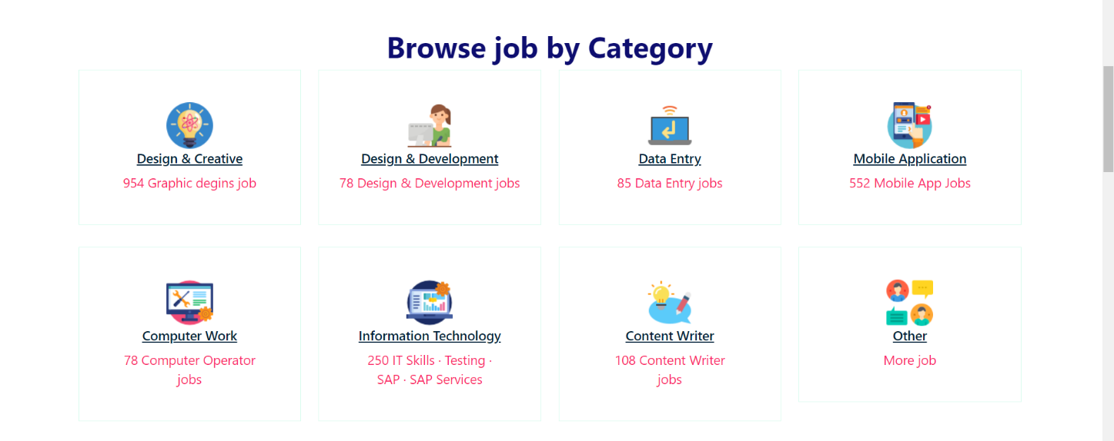



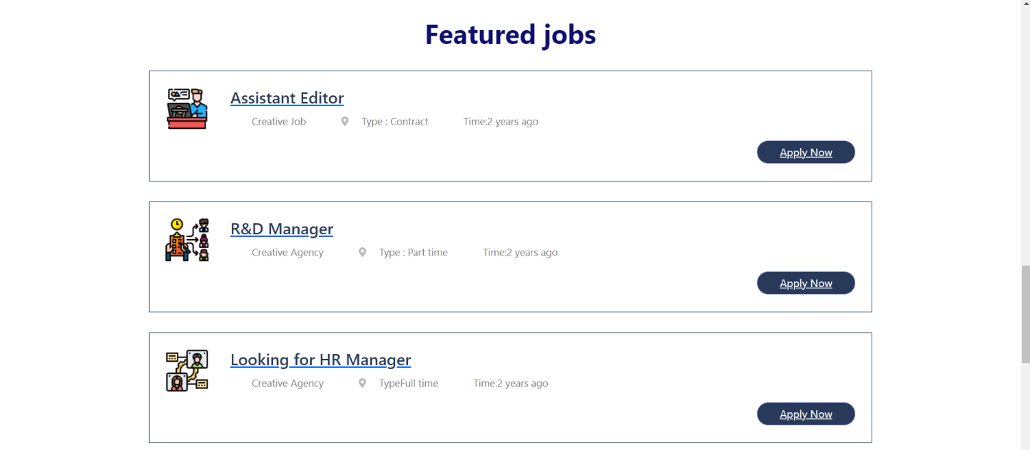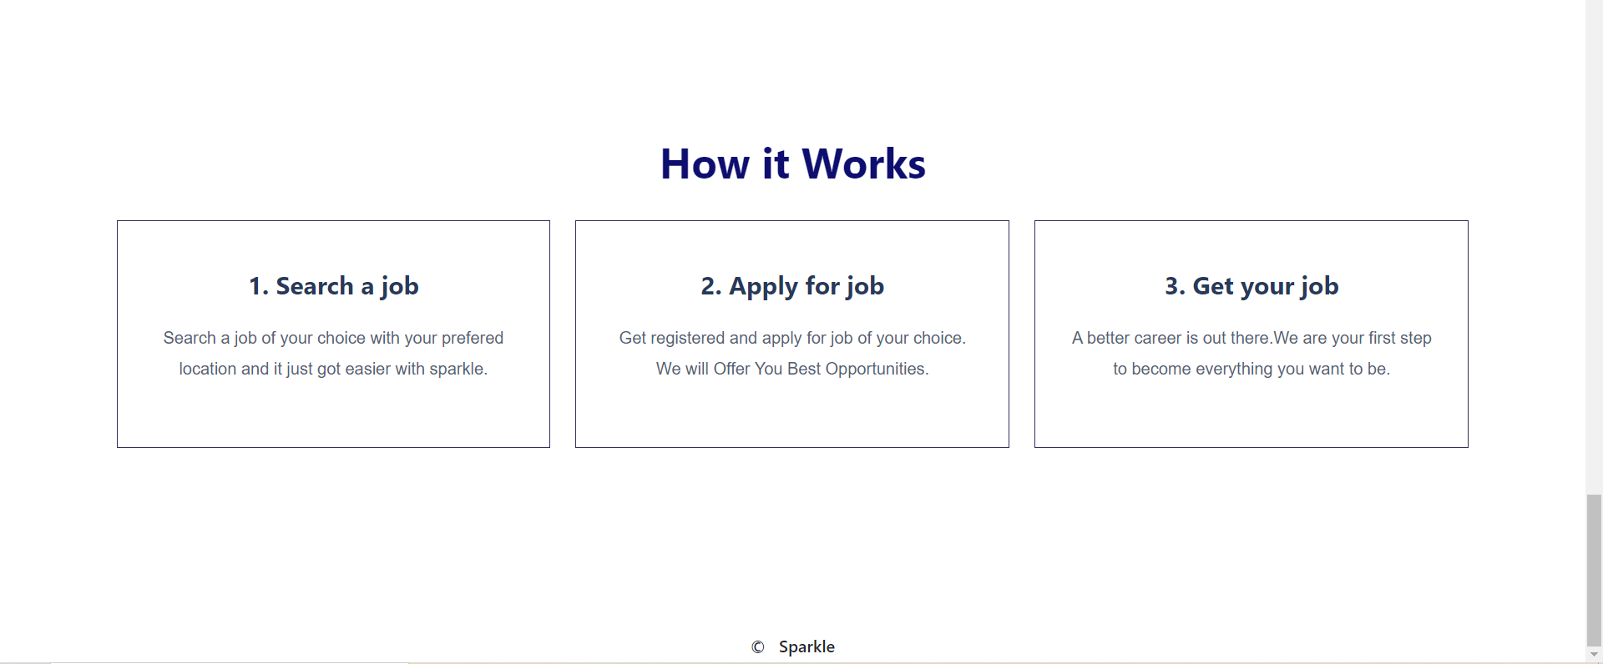

* 1. **Login Screen:**

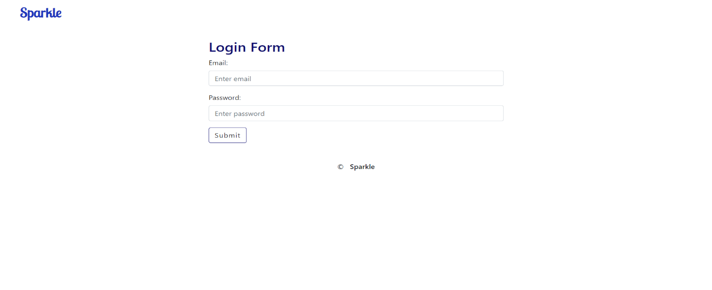

* 1. **Registration Screen:**

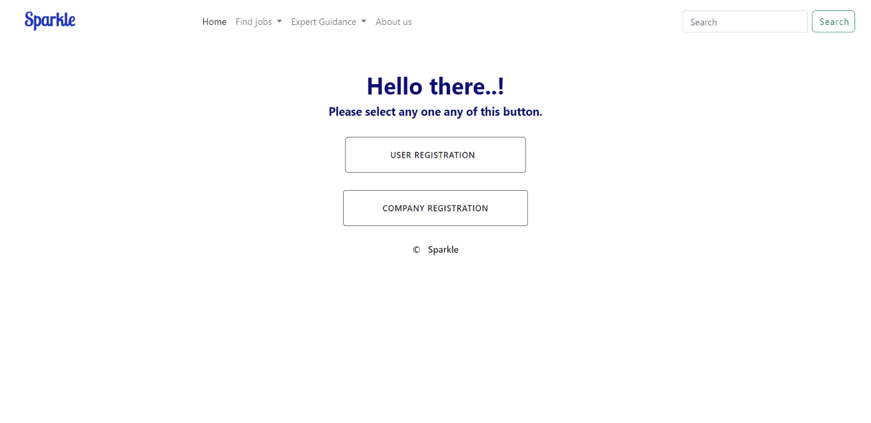

**User registration Screen:**

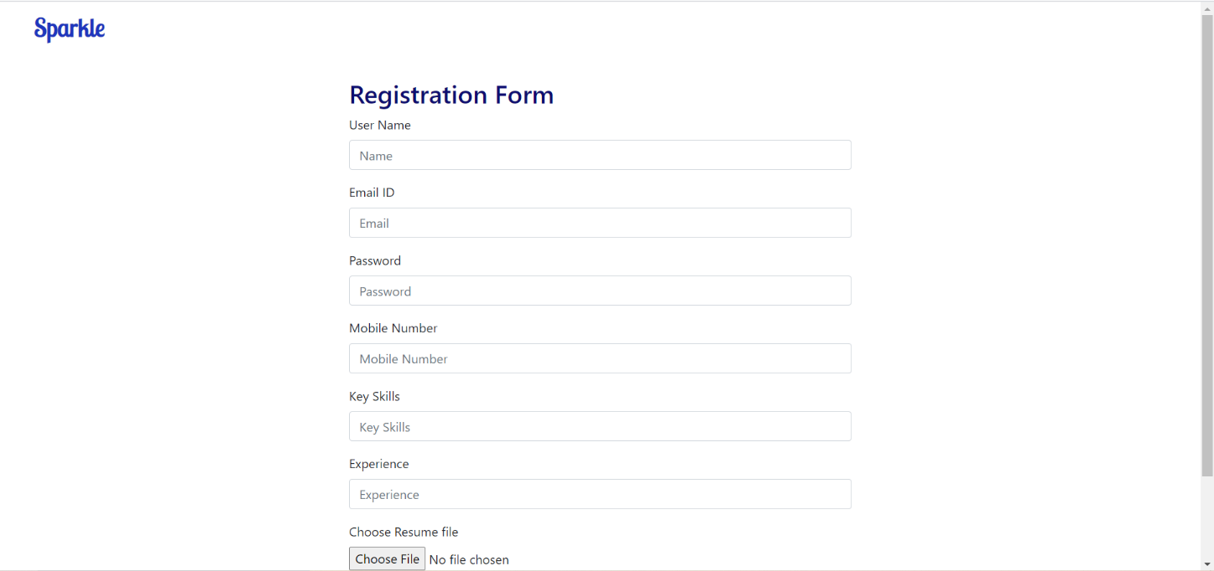

**Company registration:**

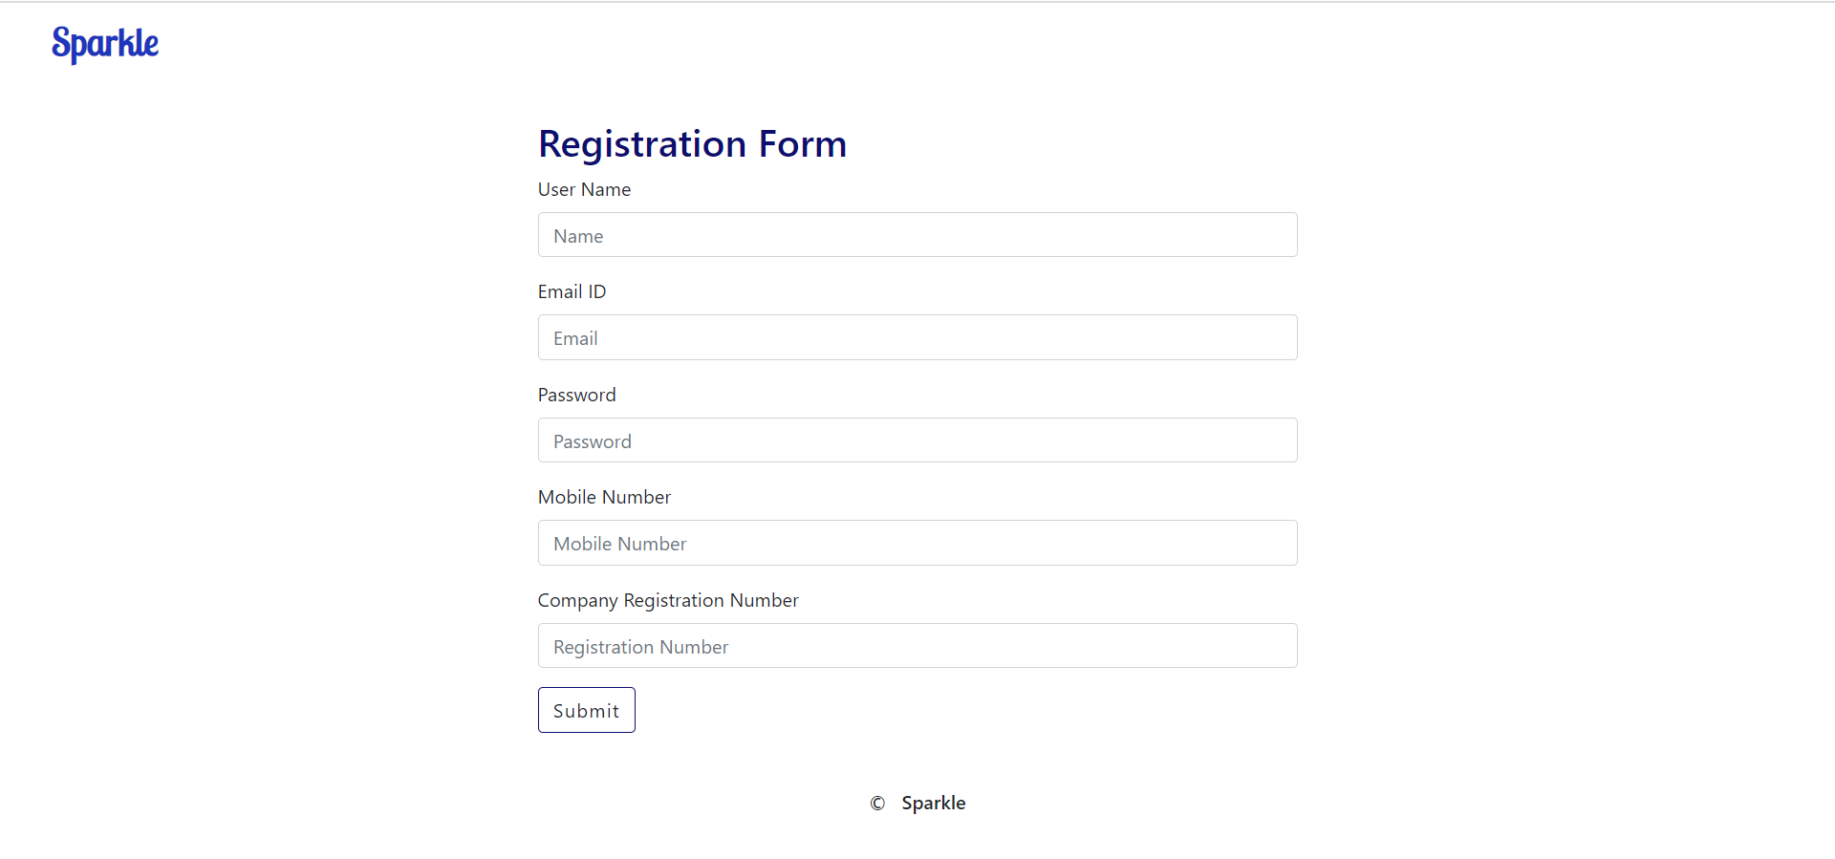

**Plagiarism**

PLAGIARISM SCAN REPORT

|  |  |  |  |  |  |  |
| --- | --- | --- | --- | --- | --- | --- |
| Words | | 1081 | Date | | | October 15,2020 |
| Characters | | 6836 | Exclude URL | | |  |
| 2%  Plagiarism | 98%  Unique | | | 1  Plagiarized  Sentences | 47  Unique Sentences | | |

Content Checked For Plagiarism

In this 21st century, the education among the people is increasing that the jobs for them are

now decreasing. Some people are multitasker .Even the companies want the people who are

best or expert in their fields or post .At that particular time, it becomes difficult and time

consuming to hire the candidate who is smart and intelligent enough at their work and at the

same time honest also. The aim of our project is to develop an online job portal for job

seekers and company manager in more convenient way.

Job portal is a website which connect employer and job seekers where employers are the

person who post and delete the job andthe job seeker can find and apply for the job of their

choices. This project will allow the candidate to apply for a job of their choice and vacancy

available at company.

Our Online Job Portal is a web application. Our aim is to developed an interactive website

which help job seeker to find a job related to their skills and choice. The objective of our

project is to provide features and functions to jobseekers to post or upload their resumes and

find appropriate jobs while companies can post their job vacancies and find eligible candidates.

It enables job seekers to post their resume, generate their resume, and generate video resume

search for jobs, view job listings. It will provide companies to place their vacancy job list on the

site and have an option to find an eligible candidate for that position.

**The purpose** of our Job Portal is to give the job seekers a platform for finding a right and

satisfactory job according to their qualification or choices. It connects the job seekers, employer

and company. Job Portal is prepared for all categories of job and help to get the various types of

job to the job seeker. The main purpose of job portal is to provide the more convenient and easy

way to get job to the job seekers

.

**The scopes are mention below**: It will contain all the information of Company, Employer and

job seekers. It will contain all the information of Job Seeker like Personal Details, Professional

Details, Educational Details, etc. which are present in database.

It will process and evaluate jobs registered by the companies It will contain information related to Job Expiry.

It will maintain Job Seekers, Employer and applied candidate records.

It will maintain uploaded resumes in database will full privacy.

**User Characteristics**

It describes the type of user which deals with the applications. This website has three types of

users or module as given below:

1. Admin

2. Employer ( Manager)

3. Job seeker

1. Admin: This module provides admin related functions. Admin can manage entire website

and will also maintains the profiles of applicants, registered candidate and employers.

1. Employer: This module provides functions related to employers. Employers can post

vacancy details and update the details as and when necessary and delete when vacancy is

filled. Employers can go through candidate resumes based on different criteria related to

their job position.

1. Job seeker: This module provides functions related to job seekers. Candidate can post

their resumes or use feature video resume to generate video resume. The applicant can also

search through the present vacancies available. Job seekers can also get notifications when

their resumes are selected by employers or when there is any vacancy related to their choice

or qualification

.

**Study of Current System**: Currently there are many applications and website but there are some

problem in those apps and website like authentication, verification and many more.

**Requirement of this System :** We are developing an online job portal. By using this portal, the

job seeker and employer will task become easy and job seeker can search their jobs related to

their choice and company can get eligible candidate in very efficient and convenient manner.

We are developing our portal on this interactive concept

**Main Modules:** The Online Job Portal will be used to manage jobs. It will support both job seeker

and Employer to achieve their goals. The main modules involved in this system are:

1. Admin
2. Job seeker
3. Employer
4. Administration Module : This module provides administrator related functionalities. Admin

will manage entire application and maintains the profiles of applied candidate, job seekers

and employers.

1. Job Seeker Module: This module provides functionalities for job seekers. Job seeker can upload

their resumes. Job seekers will notification when their resumes are selected by employers. The

job seeker can search through the present vacancies available in any company.

1. Employer Module: This module provides functionalities related to employers. Employers can

post job vacancy details and update the details as and when necessary depending upon company

criteria. Employers can search through applied candidate resumes based on different criteria of

company.

**Justification:**

The wider areas of job searching improve the quick and easy access to opportunities which will be helpful to every jobseeker. The situation has prompted many to move to job portal to look for the ways that has been widely accepted and fully useful in job searching and at the same time easy to access .

**Pseudo code or algorithm**

Admin side : Step 1: provide user name and password

Step 2: if username and password both is correct then it will login successfully.

Step 3: it shows home page

Step 4: admin can able to perform many operations.

User side : Step 1: login to the system.

Step 2: job search as per candidate choice and location.

Step 3: Apply for the job as per user choice .

Step 4: if applied for job then give test or interview.

Step 5: logout from the site.

Employer : Step 1: login to the system.

Step 2: post ,delete or update the job vacancy.

Step 3: select the candidate as per requirement of company.

Step 4: conduct the interview of selected candidates.

Step 5: logout from the site.

|  |  |  |  |
| --- | --- | --- | --- |
| |  | | --- | | Sources | | |  | | --- | | Similarity | |
| |  | | --- | | College Management Full Document | Inheritance (Object Oriented...)  the main modules involved in this system arewe are committed to bring the best way of management in the various forms of campus management system. we understand that campus management system in not a product to be sold, it is a bridge between the college and students.  <https://www.scribd.com/doc/20699065/College-Management-Full-Document> | | 3  % |

|  |  |
| --- | --- |
|  |  |
|  |  |